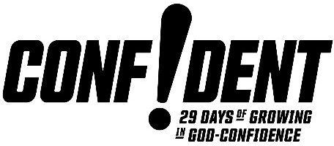

Doing Life With God
1 John 1:1-2:2

Fellowship
- We have been brought into fellowship with the FATHER
and the SON. 1:3
- It is in Him that we have our true fellowship with
ONE ANOTHER. 1:3
- All of this happens in and through the HOLY SPIRIT. 4:13

Light
- God is light. 1:5
- To do life with God is to walk IN THE LIGHT as He is in the light. 1:7
- To live in the light is to live a WITH-GOD life.

And:
- The blood of Jesus CLEANSES US from all sin. 1:7
- The Father is faithful and just to FORGIVE US our sins and to cleanse us from all unrighteousness. 1:9
- Jesus ADVOCATES for us with the Father. 2:1
- Jesus is the PROPITIATION for our sins. 2:2

There Is A Fountain Filled With Blood
1 There is a fountain filled with blood  Drawn from Immanuel's veins;  And sinners plunged beneath that flood,  Lose all their guilty stains:  Lose all their guilty stains,  Lose all their guilty stains;  And sinners plunged beneath that flood  Lose all their guilty stains. | 4 E'er since, by faith, I saw the stream  Thy flowing wounds supply,  Redeeming love has been my theme  And shall be till I die:  And shall be till I die,  And shall be till I die;  Redeeming love has been my theme,  And shall be till I die.
2 The dying thief rejoiced to see  That fountain in his day,  And there may I, though vile as he,  Wash all my sins away:  Wash all my sins away,  Wash all my sins away;  And there may I, though vile as he,  Wash all my sins away. | 5 When this poor lisping, stamm'ring tongue  Lies silent in the grave,  Then in a nobler, sweeter song  I'll sing Thy pow'r to save:  I'll sing Thy pow'r to save,  I'll sing Thy pow'r to save;  Then in a nobler, sweeter song  I'll sing Thy pow'r to save.
3 Dear dying Lamb, Thy precious blood
Shall never lose its pow'r,
Till all the ransomed Church of God
Be saved, to sin no more:
Be saved, to sin no more,
Be saved, to sin no more;
Till all the ransomed Church of God
Be saved to sin no more.
Words: William Cowper.Traditional American Melody: Arranged Lowell Mason. Celebration Hymnal, p. 336. © 1998 by Word Music/Integrity Music. CCLI: 312522

T. J. Leach, East Campus Pastor
New Life Church/February 2, 2020

